TITLE OF PAPER
Author1 Name¹, Author2 Name² (include all authors, underline corresponding author)
¹ University/ Institute of Author1
¹ University/ Institute of Author2
e-mail of corresponding author
ABSTRACT
An abstract has a single or several paragraphs, without indentation, that summarizes the key points of the manuscript in 150 to 250 words. An abstract has a single or several paragraphs, without indentation, that summarizes the key points of the manuscript in 150 to 250 words. An abstract has a single or several paragraphs, without indentation, that summarizes the key points of the manuscript in 150 to 250 words. An abstract has a single or several paragraphs, without indentation, that summarizes the key points of the manuscript in 150 to 250 words.
An abstract has a single or several paragraphs, without indentation, that summarizes the key points of the manuscript in 150 to 250 words. An abstract has a single or several paragraphs, without indentation, that summarizes the key points of the manuscript in 150 to 250 words. An abstract has a single or several paragraphs, without indentation, that summarizes the key points of the manuscript in 150 to 250 words. An abstract has a single or several paragraphs, without indentation, that summarizes the key points of the manuscript in 150 to 250 words. An abstract has a single or several paragraphs, without indentation, that summarizes the key points of the manuscript in 150 to 250 words. An abstract has a single or several paragraphs, without indentation, that summarizes the key points of the manuscript in 150 to 250 words.
Keywords: writing, template, sixth, edition, self-discipline, good (maximum 6 words)
Topic:

1. PARAGRAPH FORMAT AND STYLE
The full extent of the paper should be about 8 pages.
The final document shall be send in pdf and in MS Word format (doc o docx).
This template shall be used as a reference style. To get automatically the correct format and style, please insert your text into this template and save it as a Word format. [Basic paragraph style: Calibri, 11 pt, justified, spacing above/below paragraph 12 pt]
1.1 Lists
The paragraph style for lists is as follows:
- List 1 [Calibri, 11 pt, justified, hanging indentation 0.63]
- List 2
- List 3
1.1.1 Figures and photographs
The paragraph style for figures is as follows, including the figure caption:
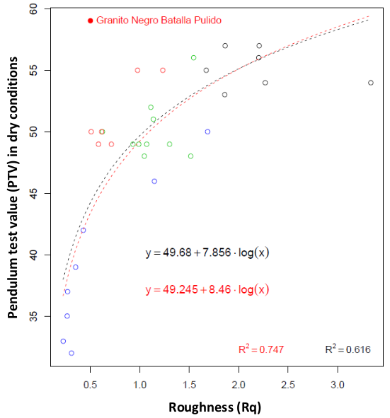
Figure 1: Caption [Calibri, 10pt, centred]
In order to access correctly the information, images and photographs must have an appropriate resolution and quality. Verify the quality in the pdf format.
1.1.2 Tables
The paragraph style for tables is as follows, including the table caption:
Table1: Calibri, 10pt, centred
Format | Format¹ | Format²
Size | 10 pt | 10 pt
Spacing | Above 6 pt | Below 6 pt
1. Table note. Calibri, 8pt, justified, spacing above/below paragraph 6 pt
2. Table note. Calibri, 8pt, justified
1.2 Equations
The paragraph style for equations is as follows, including the equation caption:
$A=\frac{1}{n}\sum_{i=1}^{n}{xi}$ (1)
2. REFERENCES
Recommended style citation: APA (American Psychological Association)

